Contents
1 Introduction 1
2 Scope 1
2.1 Architecture 2
2.2 Design 2
2.3 Coding 2
2.4 Testing 2
3 Example walk-through 2
3.1 Architecture 3
3.2 Design 4
3.3 Coding 16
3.4 Testing 19
4 Appendices 20
4.1 People 20
4.2 References 21
4.3 Open Issues 21
4.4 Document History 21

Introduction
This demo is intended mainly as an introductory learning material for anyone within Symbian who is thinking of designing or coding for the asynchronous, event driven environments.

Scope
Within the scope of this demo we will try to show the approaches involved in the development of complex implementations for asynchronous environments as taken by the Freeway architects, designers and coders (members of the Converged Comms Team).
We have grouped these approaches into four categories: architecture, design, coding, testing.
While different people are usually involved at different stages, we believe it could be very useful to show the whole picture.

Architecture
In this section we will attempt to show how it all starts form defining component object view of your particular domain.
Initial input to this step is the problem domain view (which is outside of the scope of this document).
Output from this step is to recognise entities and their roles.
We will then try to identify relationships between these entities and give them clear names.
Normally these steps are iterated as many times as necessary until they produce a nice, elegant model for your domain. The iteration is based on interaction between the created component object view and the use-case views being described in section 2.2.

Design
In this section we will show steps leading to (please note that the following bullet-points iterate themselves):
- Definition of precise protocols for all of the previously named relationships.
- Definition of concrete messages (names + signatures) involved in the protocol’s exchange.
- Collaboration and/or sequence diagrams.
- Activity diagrams.
Output from this step is a set of use-case views showing what we need to implement.

Coding
In this step we will show common practical problems to solve and how the Mesh Machine helps solving them.
After coding an activity we will use the Mesh Machine Activity Diagram Generator tool (http://loncoredev01.intra/mmadg/) to verify that the written code matches what designers have specified in their activity diagrams produced in the previous section.

Testing
In this section we will show how to use the trace visualisation tools to automatically produce complete sequence diagrams at run time (for example within the debugging session).
These diagrams are a great way of documenting and explaining the dynamic behaviour of the system (for example when talking to licensees).
The visualisation test suite is currently located under: /common/comms-infras/tools/.
Produced outputs should be compared to the output from the design section hence verifying implementations of our protocols.

Example walk-through
Here we will walk through our demo showing why, what and how we have done at every step of the development cycle.
Our demo consists from the following components:
1) The test application (testnode.exe) – driving the example,
2) A dummy transport implementation (dummytransportimpl.dll) – providing a simple learning alternative to the proper transport used in real implementations like Freeway,
3) A dummy state library (dummystatelibrary.dll) – where the protocols, messages, states, state forks, transitions, activities and node base classes are defined,
4) A dummy nodes ECom plugin (dummynodes.dll) – where our concrete dummy nodes are defined.

Architecture
We have chosen our example demo domain to be purposely simple.
It is worth noting here that our example domain is entirely agnostic to any particular technology domain you may or may not be familiar with. In particular it is not same or similar to the New Comms Architecture (Freeway), except when it uses the same universal approaches (e.g. protocols) or commonly used patterns (e.g factories), etc.
Our domain is also entirely agnostic to the threading model. Nodes could be hosted in the same thread or different threads or processes.

In accordance with 2.1 we have identified several roles within our model:

Factory Client
A Factory Client can make a request to the Factory to create a new node(s).
The Factory is assumed to be always present.
Because the lifetime of the Factory is not controlled by the Factory Clients and because it is always present there is no requirement on the Factory Clients to perform any binding procedures before requesting object(s) creation.

Factory
On successful instantiation of an object, the Factory sends a response to the Factory Client. Otherwise it responds with an error.

Client
In our example Clients logically control lifetime of their Service Providers – this forms part of the Client’s role.
Because of the nature of the relationship Clients must join (bind to) its Service Providers before requesting any further services.
After the binding completes successfully a Client can start sending requests to the Service Provider (i.e. Start) – one at a time.
The Client can cancel any of its cancellable outstanding requests at any time.
After the Client has finished using services of its Service Provider it can leave (unbind from) the Service Provider.

Service Provider
Service Provider nodes are created by the Factory when their first Client requests them.
Service Provider nodes destroy themselves when their last Client leaves and when there are no outstanding join requests pending (more info about that later when describing the Client Joining activity).
Service Providers serve join requests from their Clients. They also serve other requests (e.g. Start) from Clients that are already joined.

In accordance with 2.1 we have identified the following objects (nodes) implementing the above mentioned roles:

Factory (behind a Factory Container)
Role: Factory (to instantiate new or find already created nodes)

Test Node
Role1: Factory Client (to request creation of Node1)
Role2: Client (to send requests to Node1)

Node 1
Role1: Factory Client (to request creation of Node2)
Role2: Client (towards Node2)
Role3: ServiceProvider (towards the TestNode)

Node 2
Role: Service Provider (towards Node1)

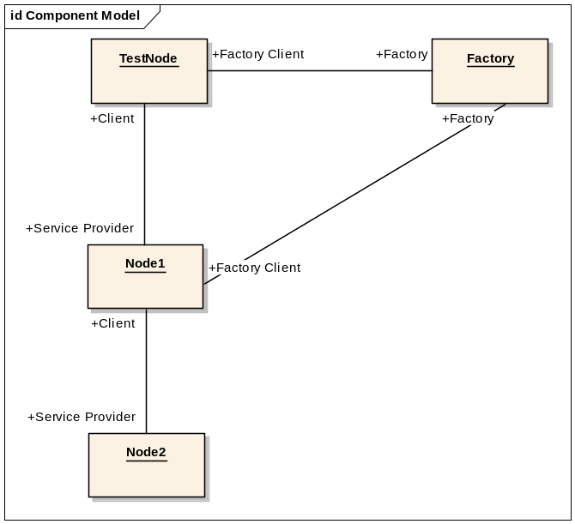
Figure 3-1
Model of our simple demo domain shows objects involved and their respective roles.

Design
In this section we will define exact protocols for each role, messages, as well as provide collaboration and activity diagrams.
When designing protocols and later activities for asynchronous environments, one of the main issues that need to be carefully considered is around object lifetimes and this especially around error conditions. In fact this is one of the reasons why we have introduced the binding protocol.
For starting, the binding protocol must be safe. For example what happens when a Client that requested an object from the Factory fails to join it? Or what happens when the Client’s join request completes successfully but subsequently the Client fails to append the node to its peers’ array? Or what happens when two different Clients request creation of the same object at the same time? Or what happens with the created object when one of the Clients succeeds while the other fails to join it? Or what happens in numerous other potential error scenarios?
All of these questions must be asked and carefully answered before we can have any reasonable confidence in the protocols and activities implementing them that we are defining.
Another difficult area is error handling in general. The Mesh Machine default error handling provided in a form of an Error Activity usually greatly simplifies the design as the designer does not need to explicitly define by far the majority of the possible error paths.
But really, even though the majority of the error paths are handled by the Error activity, we say that a successful protocol and/or activity designer must go through every possible step of the protocol asking what would happen if:
- An error was returned instead of the expected successful response?
- Any of the local actions (modelled by transitions in the Mesh Machine) generated an error?

When defining our protocols one of the most important questions we need answered is which transactions may and which may not fail. Then activities must be designed to reflect that. The Mesh Machine provides some very elegant and useful features that we used in our demonstration when solving this. For example the pre-allocation functionality was used to guarantee successful kick-off of certain activities (these include our Stop activity, our Client Leaving activity and our Destroy activity).

Protocols
Having defined roles and named relationships shown above on the Component Model diagram we can now start defining our protocols.
For simplicity and for clarity of our examples we have assumed that:
- From any given node to any other node there can only be one outstanding request at a time. For example, we do not allow stopping while the start request is still being processed. Before posting TStop to a node which is starting, the requestor must first wait for the start to complete or issue a TCancel to cancel its start request and wait for it to complete (TStarted & TCancel may pass each other in transport so the Client must still pay attention and act upon the successful response).
- Cancellation of certain requests defined in our example demonstration domain does not make sense and therefore is not allowed. This is true for all requests which are irreversible in nature or cancelling of which can fail. As an example, we say that cancelling of the destruction request is not possible because destruction is irreversible. Another example could be the stop request. It is not possible to cancel it because it would almost mean “start again” which is of course fallible.
- There can be multiple Clients of any single Service Provider. This means that for example TStart and TStop requests can be made simultaneously by different Clients – please see following discussion about synchronisation later on)
- There can be multiple Service Providers used by the same Client.

Each protocol’s description contains detailed information about its requests (fallible / cancellable / etc) and responses.

We will always describe the protocols as collaboration between two (or more) roles involved, and only after that we will name the messages involved in the exchange, as well as specify any potential parameters carried by the messages (signatures).

Binding Protocol (Factory Client <-> Factory and Client <-> Service Provider)
Our demo defines the Binding protocol with these requirements:
- If the Creation request succeeds the Client must subsequently request Client Joining.
- If the Client Joining request succeeds and addition of the Service Provider’s handle fails on the Client, the Client must subsequently request Client Leaving on that Service Provider.

Successful Path
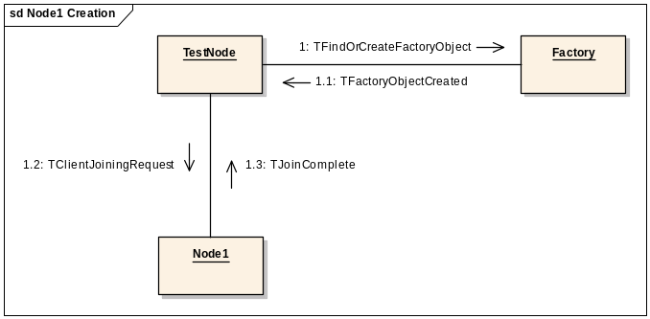
Figure 3-2 Request to create a new node or find an existing one

All possible error paths
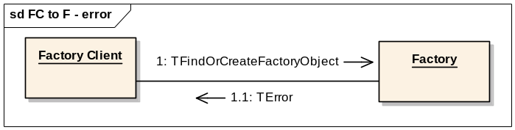
Figure 3-3 Error during node creation
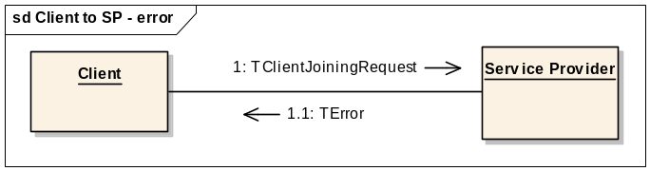
Figure 3-4 Join request failure
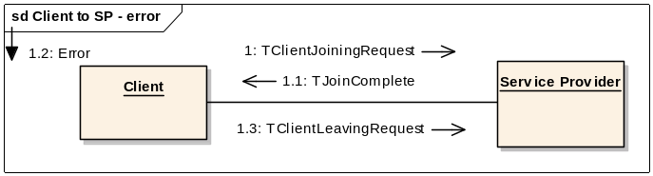
Figure 3-5 Local failure (AddClientL)

Messages

TFindOrCreateFactoryObject
[Semantics]: Sent to a factory (container) to request a factory object.
The factory object is to be pre-existing or newly created
depending on the request argument and factory logic.
[Type]: Request for TFactoryObjectCreated.
[Fallible]: Yes
[Cancellable] Yes
[Structure]:
param iUid - Uid of the object being asked for.

TFactoryObjectCreated
[Semantics]: Response to TFindOrCreateFactoryObject / etc.
Carries the actual object's address + sometimes pointer.
[Type]: Response
[Structure]:
param iCommsId - address of the new node
param iAny - pointer, if any

TClientJoiningRequest
[Semantics]: A request to add a new client to the recipient's clients' list.
[Type]: Request for TJoinComplete/Peerless
[Fallible]: Yes.
[Cancellable] Yes

TJoinComplete
[Semantics]: Adding new client to the recipient's clients' list succeeded.
[Type]: Response to TClientJoiningRequest.

Client Leaving Protocol (Client <-> Service Provider)
Our demo defines the Client Leaving protocol as follows:
- The Client must only request Client Leaving when it is joined to the Service Provider.
- The Client must only request Client Leaving when the Service Provider’s flags are all cleared (e.g. the Service Provider is not started, etc).
- The Service Provider must destroy itself when the last Client requests Client Leaving and the Factory hasn’t given away the node’s handle to any other (not yet joined) Client(s).

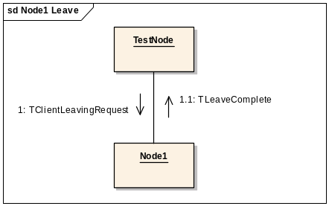
Figure 3-6 The only possible path – a successful one

Messages

TClientLeavingRequest
[Semantics]: Request to sign off out from the recipient clients' list.
The difference between this request and TClientLeaving is the ability to
Synchronise the sender's activity with the completion of the sign-out.
[Type]: Request for TLeaveComplete.
[Fallible]: No.
[Cancellable]: No

TLeaveComplete
[Semantics]: Request to sign off out from the recipient's clients' list succeeded.
[Type]: Response to TClientLeavingRequest.

Start Protocol (Client <-> Service Provider)
Our demo defines the Start protocol as follows:
- The Client can request Start only after it is joined to the Service Provider.
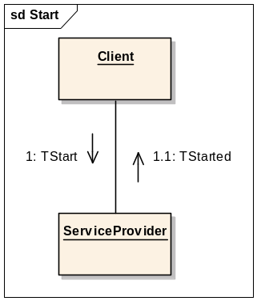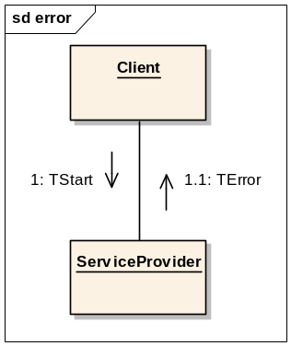
Figure 3-7 The only possible paths

Messages

TStart
[Semantics]: Request to start the recipient. The recipient should create and start
whatever it needs, to start itself. Only the very first start request
causes the recipient to invoke the start sequence, provided it is successful.
[Type]: Request for TStarted.
[Fallible]: Yes.
[Cancellable] Yes.
[Structure]:
param: iValue - dummy start parameter.

TStarted
[Semantics]: The recipient has now started.
[Type]: Response to TStart.

Stop Protocol (Client <-> Service Provider)
Our demo defines the Stop protocol as follows:
- If the Service Provider was started before, the Client must request stop before it can request client leaving.
- The Client must only request stop if the Service Provider was started before.
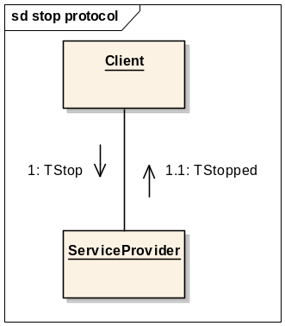
Figure 3-8 The only possible path

Messages

TStop
[Semantics]: Request to stop the recipient. The recipient should
stop and disassociate from whatever it does no longer require.
Only the very last stop request causes the recipient to invoke the stop
sequence.
[Type]: Request for TStopped.
[Fallible]: No.
[Cancellable] No.

TStopped
[Semantics]: The recipient has stopped.
[Type]: Response to TStop.

Internal Destruction Interface
Whenever a node needs to delete itself – for example after the last Client has left or after the Client Joining protocol exchange with the only Client has failed – the node sends itself a TDestroy message.
This is a convenient way of “delegating” all of the cleanup related functionality into one activity which then can be easily started from many different places. Please look at the code to see how nicely we have solved concurrency and race conditions there (e.g. related to new Clients requesting objects which have already started their cleanup sequences etc).
In our demonstration this interface is entirely private – i.e. we do not allow or process any TDestroy messages sent from other nodes than the recipient itself.

Collaboration Diagrams
These collaboration diagrams where each node is represented as a black box, constitute a verification approach towards the protocols we have defined previously. If some protocols were incomplete, or we have coupled more atomic protocols into a single blob, or they are just wrong this should hopefully be exposed here, and not after we have everything coded.
This means that a great deal of thoroughness must be exercised at this step.
While perhaps not every single path through a more complex model can be exercised manually, a common sense approach usually works great.

The Main Use-Case

Startup
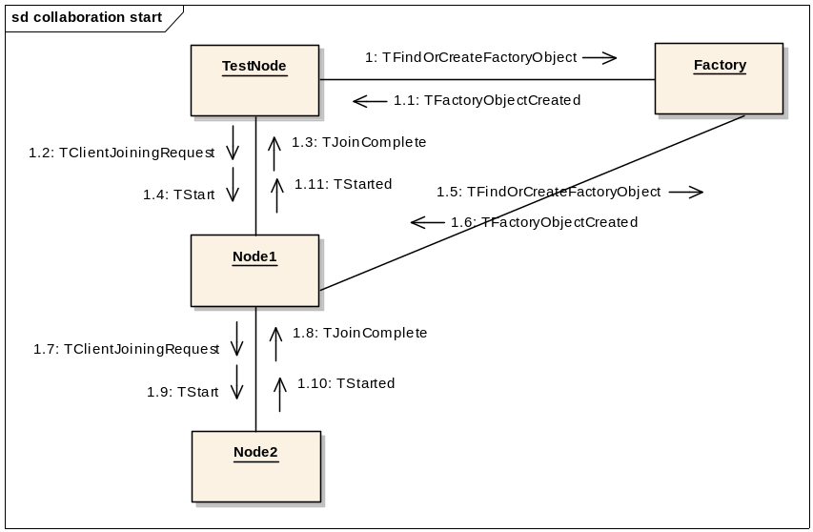
Figure 3-9 The main use-case – startup

The sequence above shows how the TestNode is driving the main use-case. TestNode must obtain its ServiceProvider from which it subsequently requests a service.

Stop
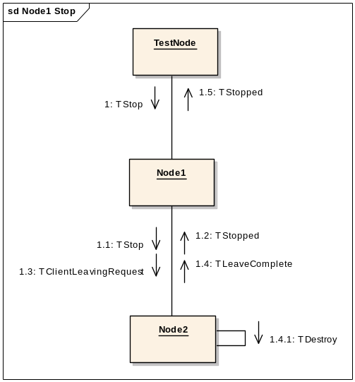
Figure 3-10 The main use-case – stop

Example of a cancellation scenario
A more careful reader would notice that after the sequence shown on the diagram below…
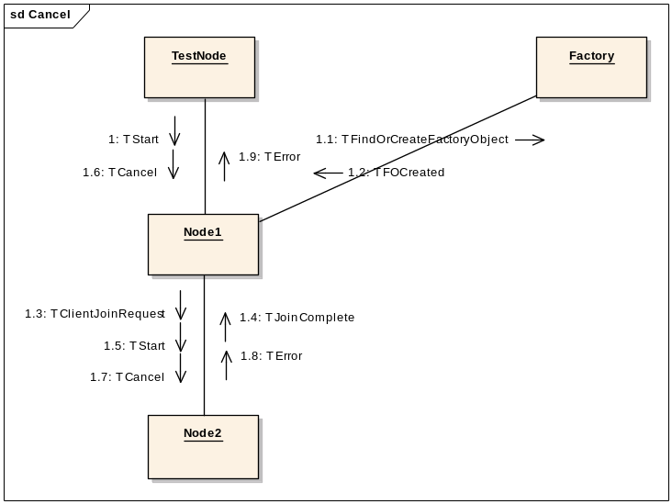
Figure 3-11 Cancellation of start
…we are left with TestNode bound to Node1 (which is not started) bound to Node2.
But we have made the Stop sequence described above to unbind Node1 from Node2 and in this case, since Node1 is not started, the Stop sequence will not happen (unless of course the TestNode choses to Start Node1 again and that succeeds). So how would the Node1 unbind from Node2 then? Please take a look at the Destroy activity to see how to satisfy the node’s cleanup requirements.

Example of an error path
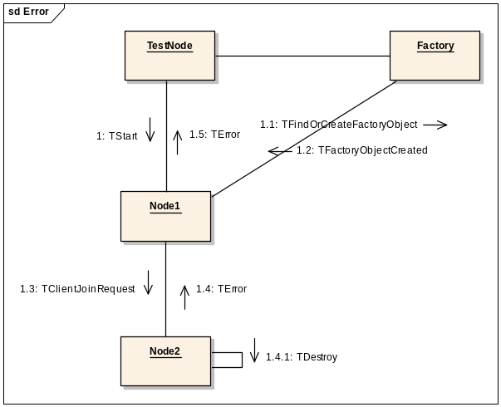
Figure 3-12
Error propagation during start failure, one of four possible for the startup sequence.

We did not show what the TestNode would or could do after receiving the TError message.
We have left this to the consideration of the reader as an exercise.

Activity Diagrams
Having defined exact protocols shown on the protocol diagrams as well as named all of the messages involved in the exchanges we can now start defining activity diagrams.
From these diagrams, you’ll notice that messages passed between nodes are “posted” rather than “sent”, the latter could imply an underlying “receive” expected. The protocols and the implementation defined here are completely agnostic to the threading model; nodes could be hosted in the same thread or different threads or processes.

Client Joining Activity
Client Joining activity is fallible and can be cancelled by its originator(s) at any time (but please see the Code section later in this document for an explanation why cancelling of this activity as implemented here does not make any sense).
This activity belongs to the “parallel activity” category, as each requestor wants to be added separately, and the TClientJoiningRequest message usually carries specific request related parameters (although not in this demo).
Please refer to [R1] for information on parallel activities and the Code section later on for why we are actually getting away with not deriving it from CNodeParallelActivityBase.
This activity first decrements the outstanding join count originally incremented by the Factory when a handle to this node was dispensed to the Client. Then it adds the requestor to the node clients’ array and responds with either success or an error message. In the error scenario and when there are no other Clients joined or joining to this node (outstanding join count == 0) it destructs the node by sending it the TDestroy request message.
It is worth noting that created nodes and their corresponding Factories always run in the same thread. Manipulation on the outstanding join count doesn’t need to be protected from potential concurrent access.

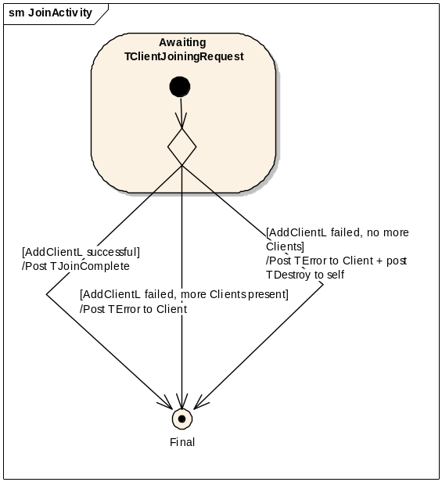
Figure 3-13

Client Leaving Activity
Client Leaving activity is not fallible and not cancellable as its actions are irreversible.
This activity removes the requesting Client from the clients’ array and responds to the Client with a confirmation (this way the Client learns that there are no outstanding messages in transport from this Service Provider and can – for example – safely delete itself).
If there are no other Clients joined or joining at this time, this activity destructs its host by sending it the TDestroy request message.

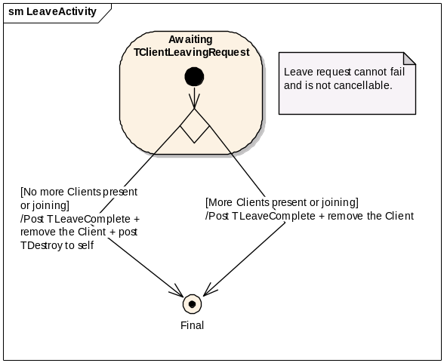
Figure 3-14

Start Activity
The Start activity is probably the most complex of our demo activities. It is fallible and it is cancellable by its originator(s).
It is not parallel and all subsequent originators (should there be more than one) are added to the originators’ array. They are all responded to after this activity has finished.
The activity’s flow takes different paths depending on the node’s current state, responses to its requests and results of the fallible transitions it employs to perform local actions, as shown in the activity diagram.
An interesting aspect of this activity is its use of the default error handling. Grey coloured flows show the default error handling provided by the Error activity. We have included the grey flows on the diagram for completeness so you can see that we have thought about them and not just forgotten about them.
As you can see custom error handling is needed only in very rare scenarios. Actually, if you see one it probably means your protocols are not as simple and optimal as they could be and you should reconsider them.
In this demo we did not have to define a single one since all of our error paths were covered by the default handling provided by the Error activity (more on error handling activities can be found in R1).
Another interesting and this time a more general aspect of this activity is that dealing with Start and Stop type of activities usually requires some form of synchronisation. Activities like Start and Stop are not usually compatible with each other as they perform mutually exclusive tasks. Taking Freeway as an example, Start from one Client can arrive at any time while Stop is being executed as requested by another Client. Freeway solves this issue by synchronising its Start activity with the Stop activity while the Stop activity just simply cancels the Start one (if there is one running on the node).
For simplicity, in our demonstration we have made both activities synchronised with each other. Start waits for Stop to complete & Stop waits for Start to complete, should these requests be made simultaneously by two or more Clients.
You can read more about synchronised activities in R1 of course.
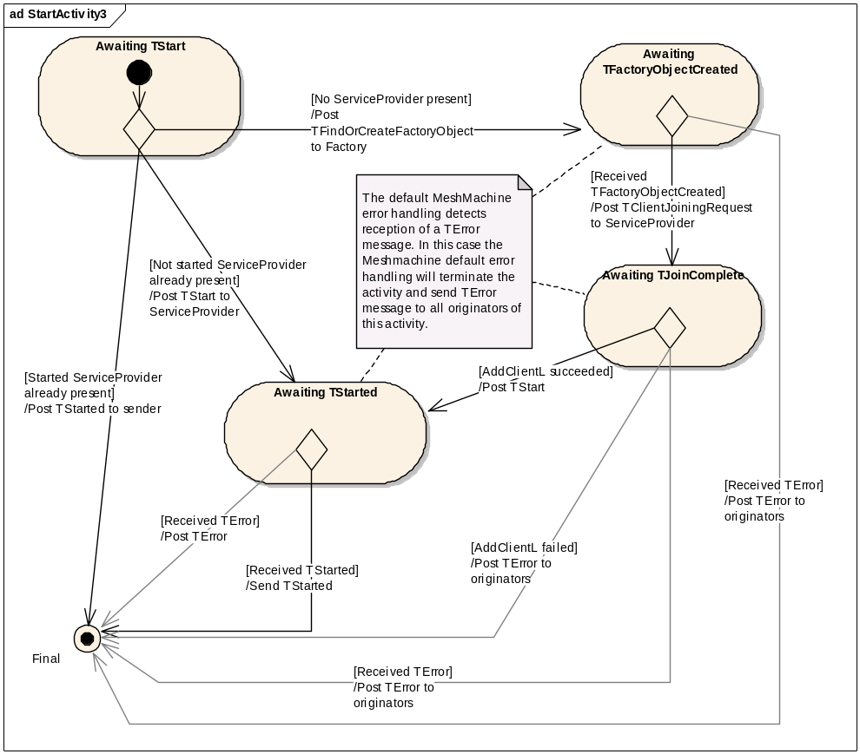
Figure 3-15
This diagram shows the base Start Activity. In our demonstration this activity is used by Node1 and potentially other nodes too.

The diagram below shows the overridden Start activity for Node2 which never has any Service Providers (because this how we decided to use it in our demo). Node2’s Start activity immediately sends a TStarted response to every TStart request.
There is an interesting point to note here: One could think that both Start activities could be easily collated together into one!
They could, of course, but the reason why this would not be a very good idea is that the Node2 is never meant to have any Service Providers while other nodes are always meant to have Service Providers. Hence these two different activity flows are always exclusive (per node) and it only becomes more confusing and more complex to maintain when one combines them.
We say that the Node2’s Start activity is a special case, while the diagram 3.2.3.3-1 is describing the general case.

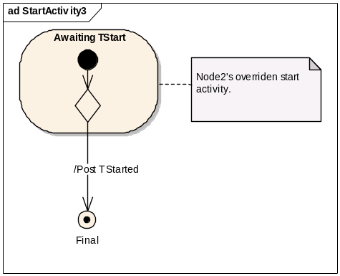
Figure 3-16
Node2’s special case overridden Start Activity

Stop Activity
Stop activity is not fallible and not cancellable as its actions are irreversible.
In accordance with the semantics of the Stop request as defined in our demonstration this activity is only invoked for the very last of the requesting Clients.
All previous Clients are simply responded to with TStopped.

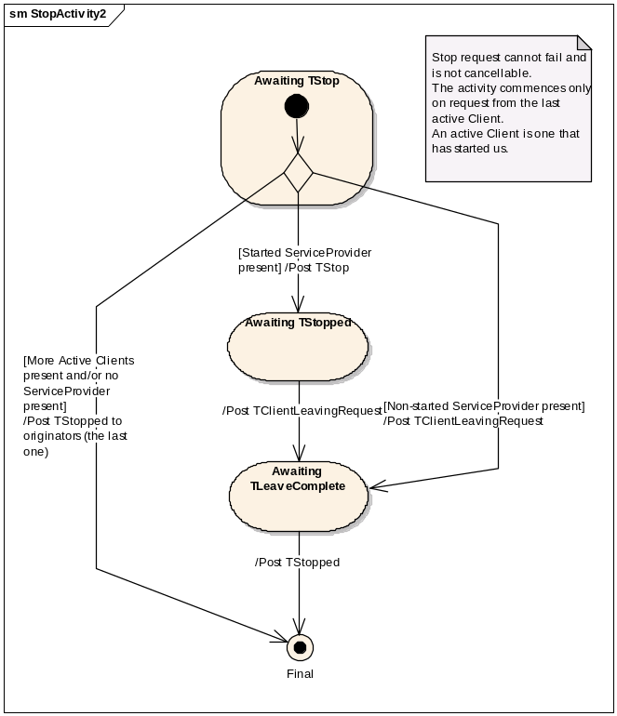
Figure 3-17

For demonstration purposes we have defined some of our nodes as Mesh Machine based (Node1, Node2) and some of the simplest ones as not Mesh Machine based (Factory, TestNode).

Coding

Our coded activities along with their generated diagrams (you need to compare these to the EAP activity diagrams produced in the design section)

Client Joining Activity
Cancelling of our demonstration Client Joining activity does not make sense as it is a single-triple one (please refer to [R1] for information on single-triple activities).
One property of these activities is that they start and finish within the duration of a single call-stack. This further means that any TCancel message would have always arrived after the activity was finished (and its originator already responded to).
Another interesting aspect of this activity is that it belongs to the “parallel activity” category, as each requestor wants to be added separately. The only reason why it does not have to derive from the CNodeParallelActivityBase is because it completes within one single call-stack and therefore will be started for every new request (please also note that single-triple activities do not need the activity object, more in R1).
DECLARE_DEFINE_NODEACTIVITY(EActivityClientJoin, DummyNodeJoin, TDummyMessage::TClientJoiningRequest)
NODEACTIVITY_ENTRY(KNoTag, DummyStates::TCommenceJoinAndAddClientAndPostJoinComplete, DummyStates::TAwaitingClientJoiningRequest, MeshMachine::TNoTag)
NODEACTIVITY_END()

Client Leaving Activity
The easiest way to implement an infallible activity is to make it a single-triple one (but not all infallible activities must be single-triple!).
In this case we have chosen this approach which also meant that we had only one transition for our disposal (single-triple activities have only one transition). You can see that the resulting transition has one action which is conditional, namely: “Please destroy self if this was the last client”.
We strongly discourage using of any transitions that have any conditional code in them! They make the activity code and diagrams a real pain to read and to understand. The ONLY acceptable place where you can actually get away with this is in infallible transitions used in single-triple (infallible) activities, where the complexity is low anyway and where you can easily benefit from added infallibility (and therefore decreased complexity of the protocol).
DECLARE_DEFINE_NODEACTIVITY(EActivityClientLeave, DummyNodeLeave, TNodeMessage::TClientLeavingRequest)
NODEACTIVITY_ENTRY(KNoTag, DummyStates::TPostLeaveCompleteAndRemoveClientAndPostDestroyIfLast, MeshMachine::TAwaitingClientLeavingRequest, MeshMachine::TNoTag)
NODEACTIVITY_END()

Start Activity
DECLARE_DEFINE_CUSTOM_NODEACTIVITY(EActivityStart, DummyNodeStart, TStartProtocol::TStart, CNodeSynchronisedActivity::NewL)
FIRST_NODEACTIVITY_ENTRY(DummyStates::TAwaitingStart, DummyStates::TNoTagOrStartedOrNoServiceProviderBlockedByStop)
//Started ServiceProvider already present
LAST_NODEACTIVITY_ENTRY(KStarted, DummyStates::TPostStarted)
//No ServiceProvider present
NODEACTIVITY_ENTRY(KNoServiceProvider, DummyStates::TCreateServiceProvider, DummyStates::TAwaitingFactoryObjectCreated, MeshMachine::TTag<KNoServiceProvider>)
NODEACTIVITY_ENTRY(KNoServiceProvider, DummyStates::TPostClientJoiningRequest, DummyStates::TAwaitingJoinComplete, MeshMachine::TNoTag)
//Non-started ServiceProvider already present
//TAddServiceProvider will post TClientLeavingRequest to the Service Provider should an error occur
NODEACTIVITY_ENTRY(KNoTag, DummyStates::TAddServiceProviderAndPostStart, DummyStates::TAwaitingStarted, MeshMachine::TNoTag)
LAST_NODEACTIVITY_ENTRY(KNoTag, DummyStates::TPostStarted)
NODEACTIVITY_END()

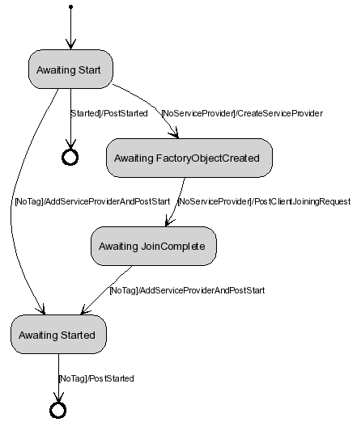
Figure 3-18

This diagram was generated with the Mesh Machine Activity Diagram Generator tool (http://loncoredev01.intra/mmadg/) from the code above it. We can now observe how well it matches with the Start activity sketched at design stage Figure 3-16.

Stop Activity
DECLARE_DEFINE_CUSTOM_NODEACTIVITY(EActivityStop, DummyNodeStop, TStopProtocol::TStop, CStopActivity::New)
FIRST_NODEACTIVITY_ENTRY(DummyStates::TAwaitingStop, DummyStates::TNoTagOrStartedOrNoServiceProviderBlockedByStart)
//Started ServiceProvider present
NODEACTIVITY_ENTRY(KStarted, DummyStates::TPostStop, DummyStates::TAwaitingStopped, MeshMachine::TNoTag)
//ServiceProvider present
NODEACTIVITY_ENTRY(KNoTag, DummyStates::TPostClientLeavingRequest, MeshMachine::TAwaitingLeaveComplete, MeshMachine::TTag<KNoServiceProvider>)
//No ServiceProvider present
LAST_NODEACTIVITY_ENTRY(KNoServiceProvider, DummyStates::TPostStopped)
NODEACTIVITY_END()
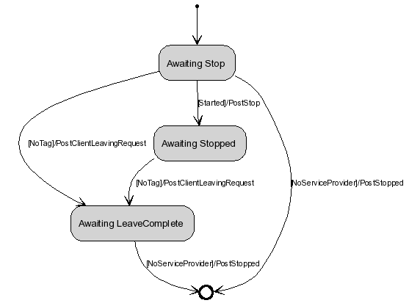
Figure 3-19

You should compare this generated activity diagram with the diagram sketched at design stage Figure 3-18.

Testing
When we run our ready test case(s), the debug visualisation tools produce at run-time a sequence diagrams that we compare to our collaboration diagrams produced under Design, section 3.2.2.
At this stage, if we see any discrepancy between our designs and the implementation, we can precisely locate the problem before even looking at the code.
In the future we would extend our debugging tools to automatically recognise patterns and show problems with a BIG, RED LINE across the diagram, so that problems can be found before they manifest in form of a defect!
We are also planning to have a fully automated history and filter anabled 3D animator tool that would allow precise visualisation of our systems for demonstration purposes.

TODO: The diagram below has been produced with incomplete tools (after productisation the tools need to be fully converted to use the new Symbian-wide tracing mechanism). Please replace the diagram below once the tool has been completed!

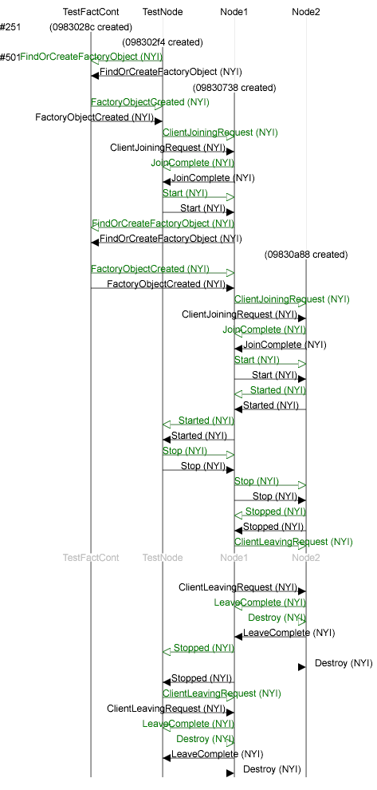

Appendices

People
Role | Person / People
Reviewers
Reviewer
Contributors
Distribution

References
No. | Document Reference | Version | Description
1 | Mesh Machine Fundamentals | Newest

Open Issues
None

Document History
Date | Version | Status | Author | Description
27-11-2007 | 0.1 | Draft | Yun Yaw Chu | New Document
28-11-2007 | 0.2 | Draft | Michal Zurowski | Structure

